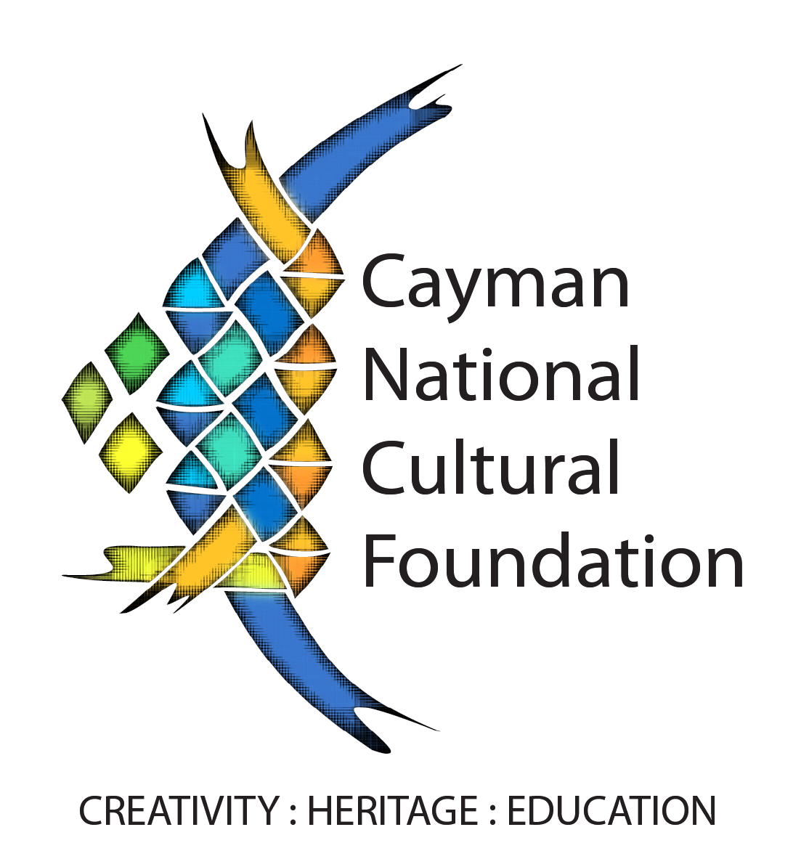
Learn Stiltwalking
Registration Form
O4 April – 08 May 2020

This training workshop covers a period of 5 weeks and will take place at the Harquail Theatre. Cost of registration is $25.00. This workshop leads to the presentation of a stiltwalking group in the Cayman Carnival parades. Participants are expected to attend 4 evenings per week on Monday, Wednesday, Friday and your choice of either Saturday or Sunday. All sessions are from 4 - 7pm unless prior arrangements are made.
Apart from attending training sessions three times per week, participants will be expected to practice in their own time.

Full Name : ____________________________________________
Parents Name (Children under 18): _________________________________________
Age: ___________________ Email Address: _________________________________
Cell Phone: __________________________________ Alt. Phone: _____________________________
School or Organization: _______________________________________________________________
Any medical condition which may prevent you from walking on a pair of stilts? ☐ Yes ☐ No
If Yes, Please Specify: __________________________________________________________________
Weight (lbs): ________________________________

By signing this Registration Form, I _______________________________ indicate that all of the above information is true. I hereby indemnify and hold harmless, Cayman National Cultural Foundation, and its employess from any liability arising from accident, injury, theft, or damages to myself, my representatives, all equipment and property under my jurisdiction.

Signature:_______________________Print Name:________________________Date:____________

